

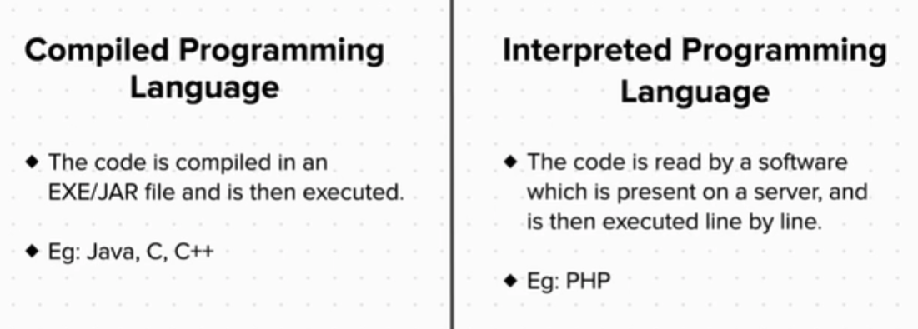









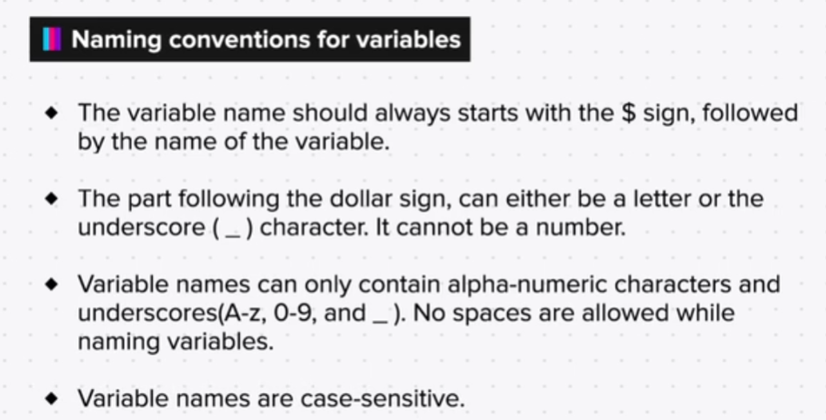





**Arithmetic Operators in PHP**

**Add**

$a=50;

$b=90;

echo $a+$b;

Output: 140

**Subtract**

$a=50;

$b=90;

echo $a-$b;

Output: -40

**Product**

$a=50;

$b=90;

echo $a*$b;

Output: 4500

**Divide**

$a=5;

$b=2;

echo $a/$b;

Output: 2.5

**Modulus (remainder)**

$a=11;

$b=2;

echo $a%$b;

Output: 1

**Exponential**

$a=2;

$b=3;

echo $a**$b;

Output: 8

**Concat (join)**

$a=50;

$b=90;

echo $a.$b;

Output: 5090

You can also do complex arithmetic operations, like we do in maths.

An example is: $a+($b+$c/($d**($a-$d)))

**Comparison and Logical Operators in PHP**

**Comparison Operators**

Now, let us look at comparison operators.

The output for these operations is always true or false.

These are:

$a==$b (check if two values are equal)

$a>$b (more than)

$a<$b (less than)

$a>=$b (more than equal to)

$a<=$b (less than equal to)

$a!=$b (not equal)

So in the first operator ($a==$b), if the value of variable ‘a’ is not equal to variable ‘b’, the output will be false. And if it is, the output will be true.

The same holds true for all these comparison operators.

**Logical Operators**

Here is a list of some logical operators that can be used.

And

Or

Xor

|| (or)

&& (and)

! (not)